System functional requirements analysis

1.1 The overall functional structure of the system

As shown in Figure 1-1, the system consists of the following functional modules:

1. Lineup Input Module

2. Data acquisition module

3. Data cleaning module

4. Model building module

5. Model training module

6. Win Rate Prediction Module

7. Output module

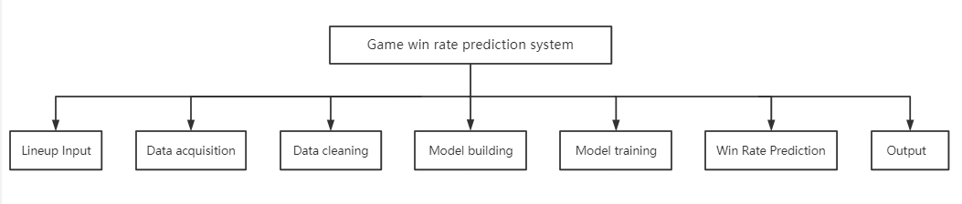

Figure 1-1 System function block diagram

1.2 Lineup input function

The main requirements of the lineup input function of this project are: the user can make the specified input of the game lineup through the given interactive interface. The input is divided into two parts, the selection lineup of 5 each of the red and blue sides. Based on the needs of the game, the 10 selected heroes need to be different.

In addition, the input function module should also be responsible for the transmission of the data stream to realize the input of data to the background.

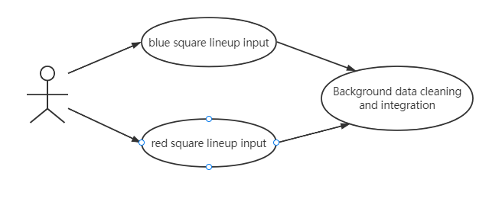1.3 Data acquisition function

Figure 1-2 Input function use case diagram

The data acquisition function mainly realizes the raw data used for model training. The data acquisition module is divided into two parts, the crawler module, and the CSV writing module.

1.3.1 Business process analysis

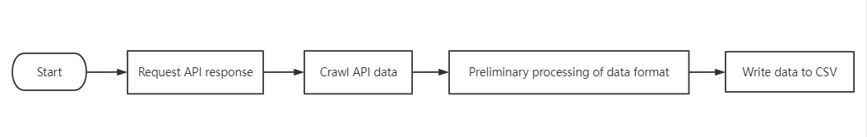Figure 1-3 is a flowchart of the data acquisition function. It has gone through the process of making requests to the api, obtaining data, initial processing and writing of data.

Figure 1-3 Data acquisition function flow chart

1.3.2 Data flow analysis

A data flow graph is an input-processing-output approach to the model data flow.

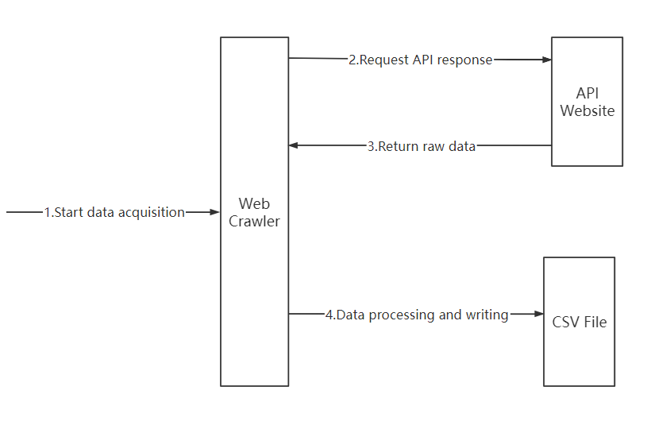Figure 1-4 is the data flow diagram of the data acquisition function module.

Figure 1-4 Data acquisition function data flow diagram

1.4 Data cleaning function

The data cleaning function needs to process the acquired raw data to make it meet the target requirements.

1.4.1 Business process analysis

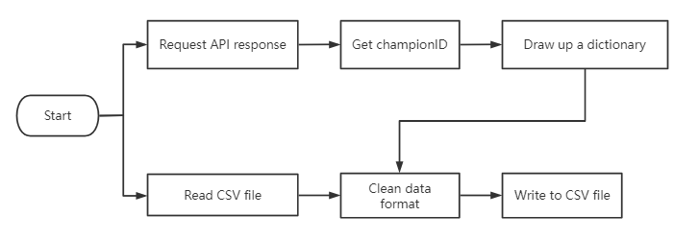Figure 1-5 shows the business flow chart of the data cleaning function. This business is divided into two parts after the start. One part needs to crawl another JSON file on the API, extract the content in the file, and rewrite a dictionary, the content of the dictionary is the champion ID corresponding to each game hero and the continuous Id given by me. On the other hand, according to the dictionary that has been written in the previous step, the original data obtained in the data acquisition module is rearranged to make it a 144-dimensional one-dimensional vector and re-written into the CSV file.

Figure 1-5 Data cleaning business flow chart

1.4.2 Data flow analysis

Figure 1-6 shows the data flow diagram of the data cleaning function:

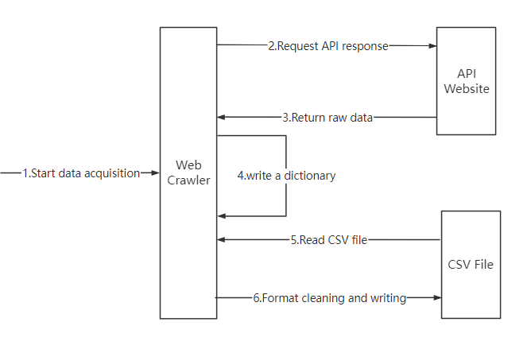

Figure 1-6 Data flow diagram of data cleaning function

1.5 Model building and training functions

Model building and training is one of the main work parts of this project. First of all, the model must be selected and built, and after the construction is completed, the model will be trained (fitted) to make it a usable model that can analyze the results of the competition.

1.5.1 Business process analysis

Figure 1-7 shows the flow chart of the model building and training functions.

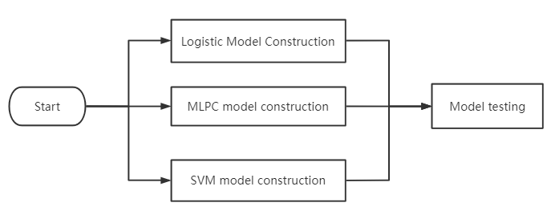Among them, three models are selected for the model selection of this system, namely the Logisitc model, the multilayer perceptron model and the support vector machine model.

Figure 1-7 Model building and training flow chart

1.6 Victory prediction and output function

The win rate prediction function is to predict the result of the game according to the data of the input module and the model that has been trained.

The output function is to output the predicted results to the UI interface.

1.6.1 Business process analysis

Figure 1-8 shows the flow chart of the win rate prediction and output function.

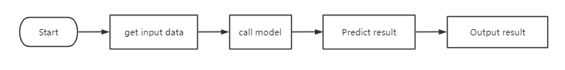

Figure 1-8 Winner Prediction and Output Flowchart